Men’s Breakfast
King’s Head Pub, High Street, Anytown
Saturday 10th September at 9.00am
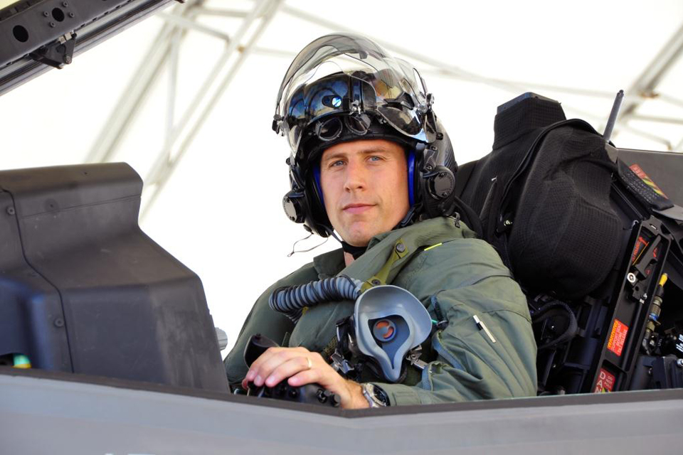
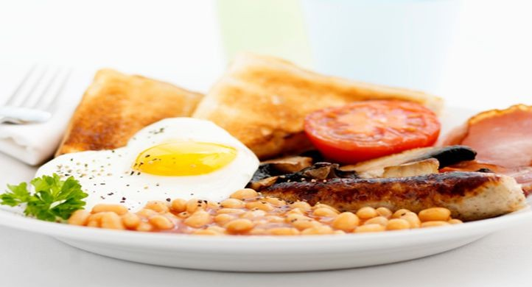

You are warmly invited to enjoy a full English Breakfast and to hear Mike Wilson speak about his life as a test pilot in the RAF, his work with disaster relief charities and the Christian faith which has transformed his life.

Tickets cost £3.00 and are available from The Kings Head, High Street, Anytown and The Parish Office of St Whatnot’s Church, Church Lane, Anytown


This event is organised by St Whatnot’s church, Anytown
www.stwhatnots.org

